**SCRUM DO SETUP**

**Step 1:** Go to www.scrumdo.com and create user ID for log in.

Create an Organization and then Project

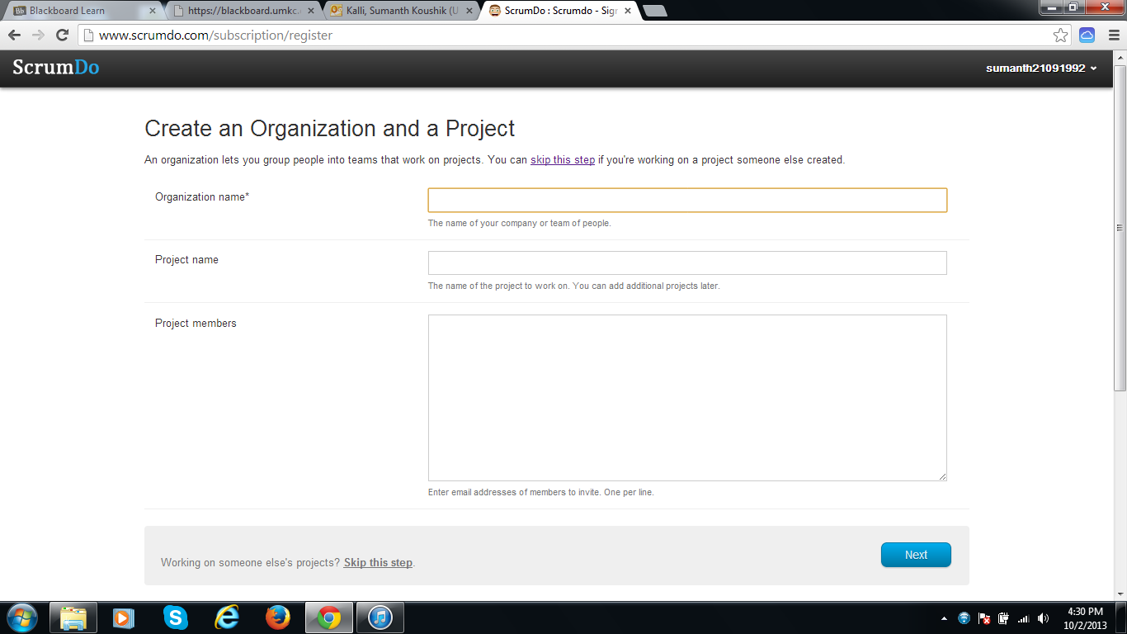

**Step 2:** Scrum Do after adding Organization and Project.

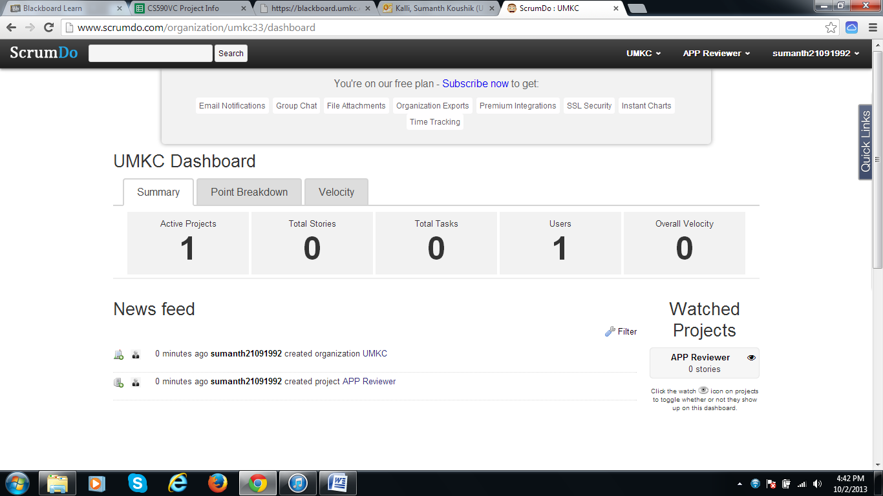

**Step 3:** Create a Story and then provide details of the story.

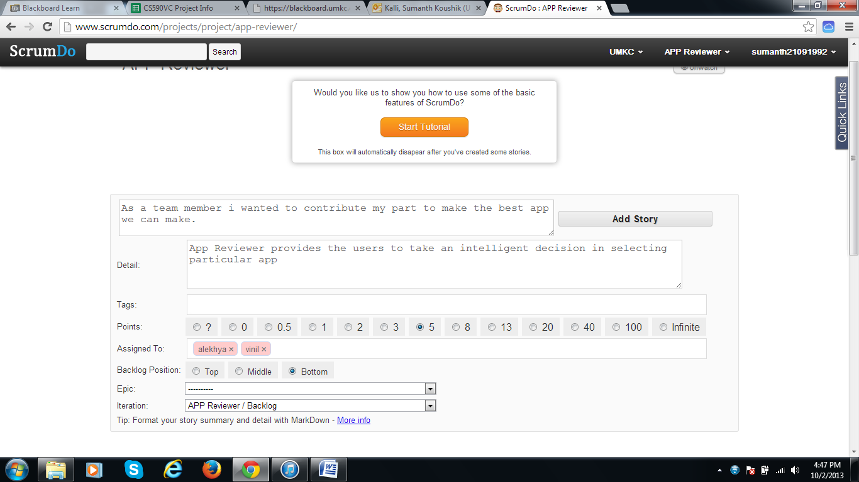

**Step 4:** Create an iteration for story and choose the story from list.

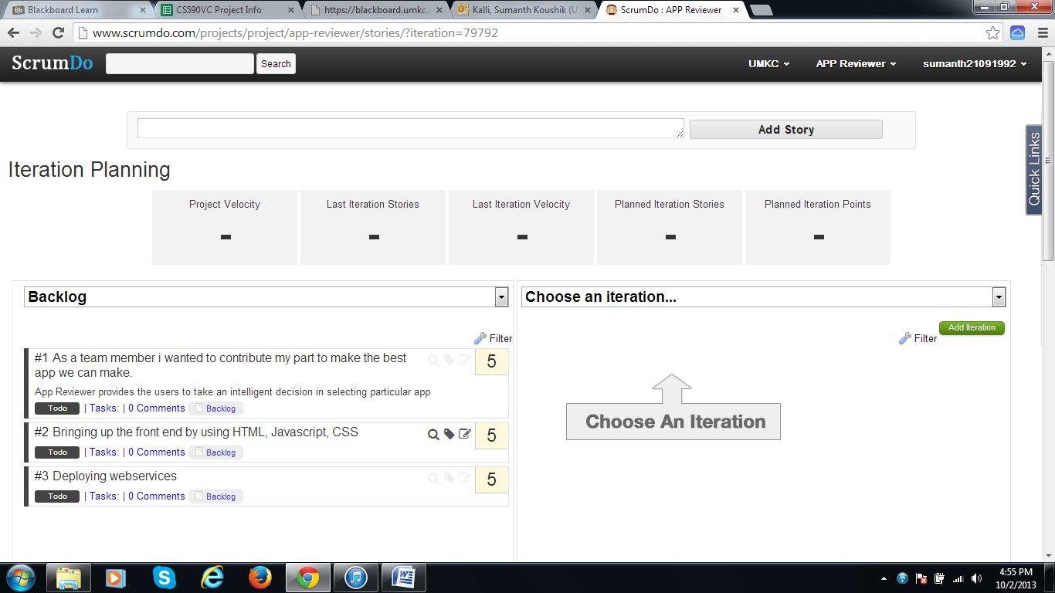

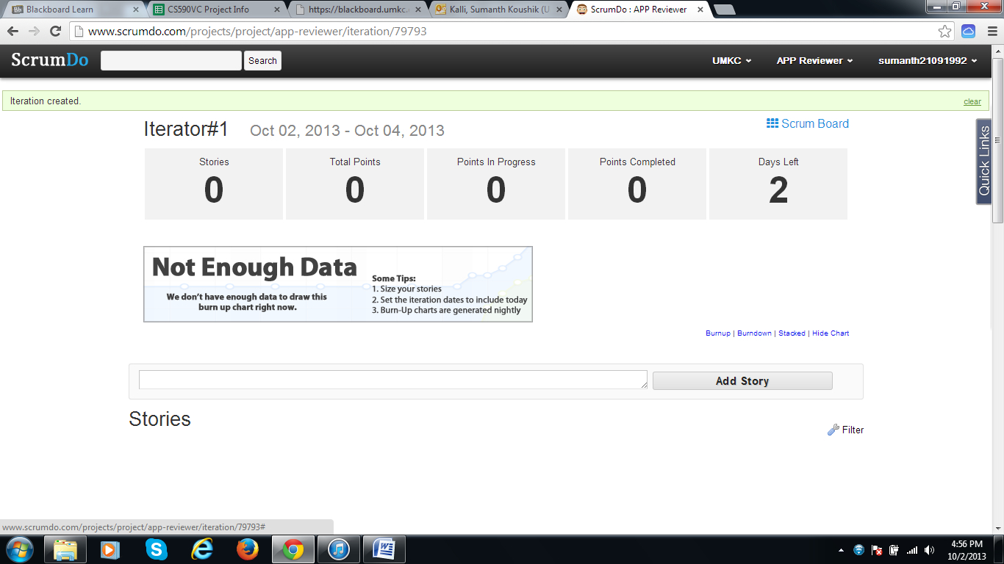

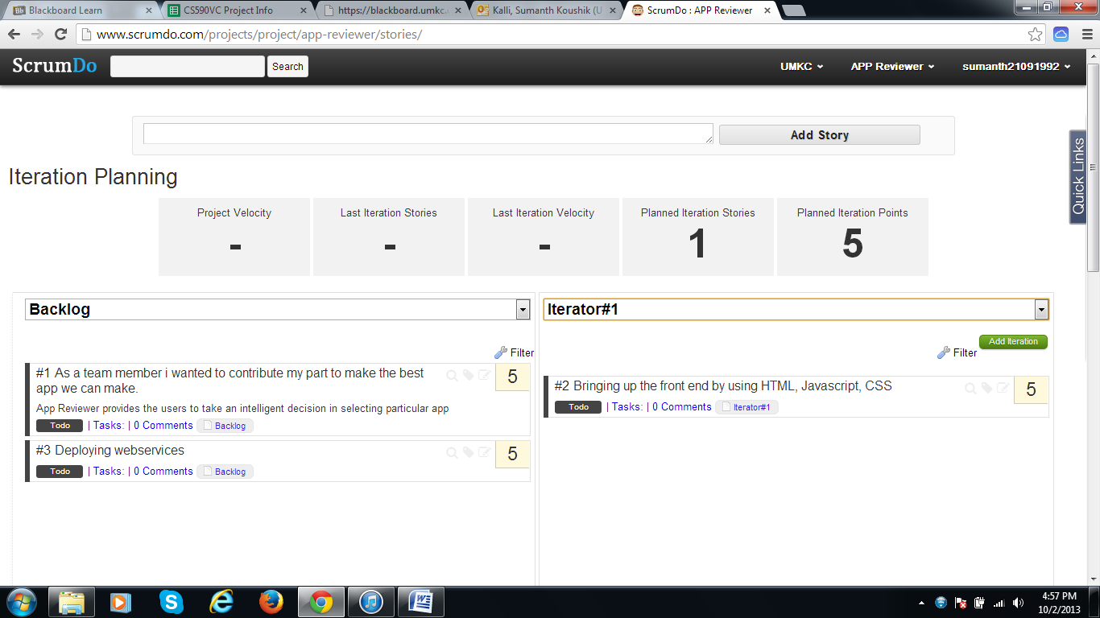

**Step 5:** ScrumDo Dash Board.

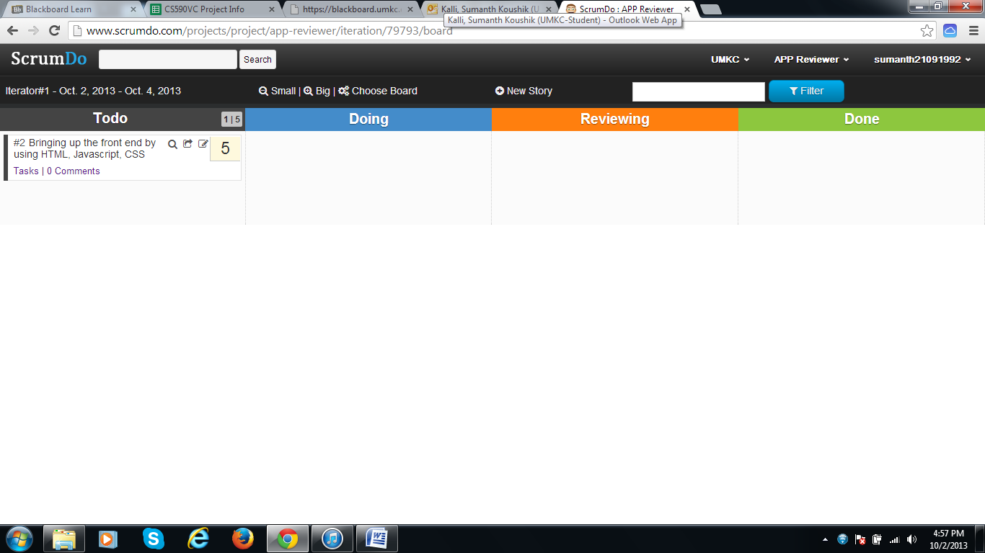

**Step 6:** Add Team to your ScumDo account for working in teams.

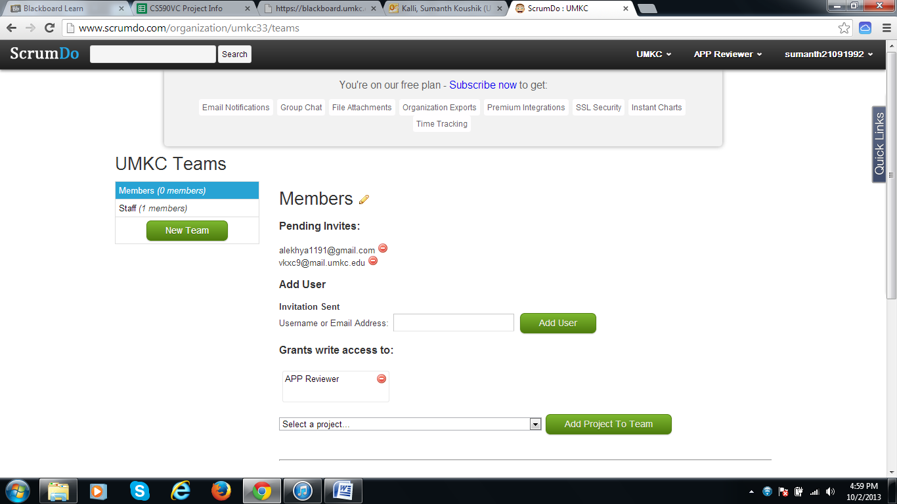

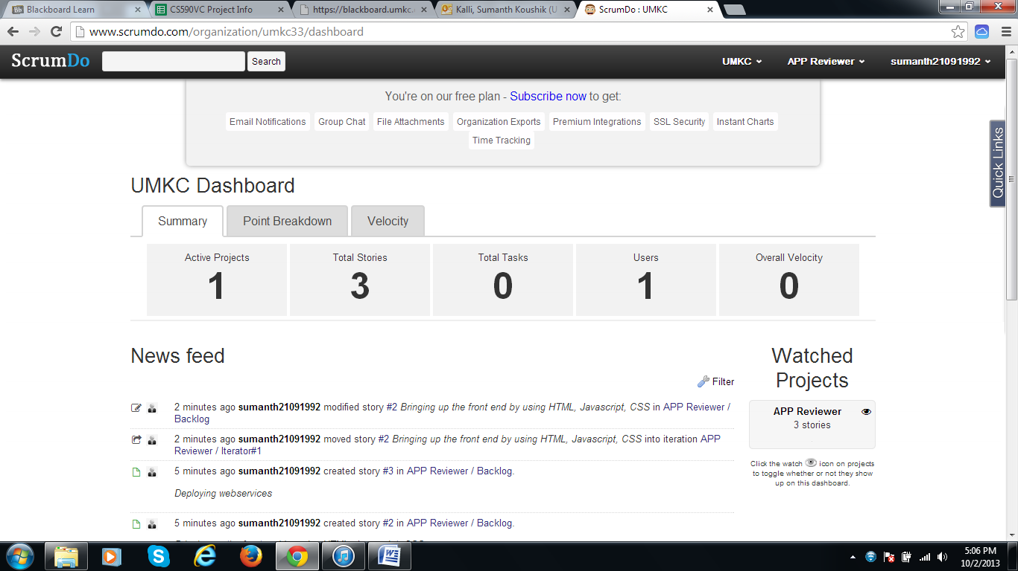

**GITHUB Account Setup**

**Step 1:** Create a GITHUB account from www.github.com



**Step 2:** Account page after logging in Github account.

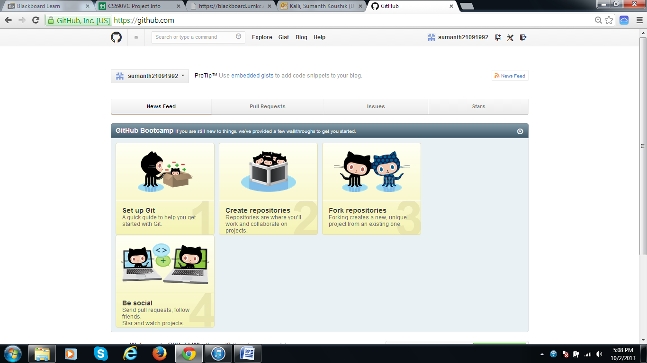

**Step 3:** Download Github for windows and then open it.

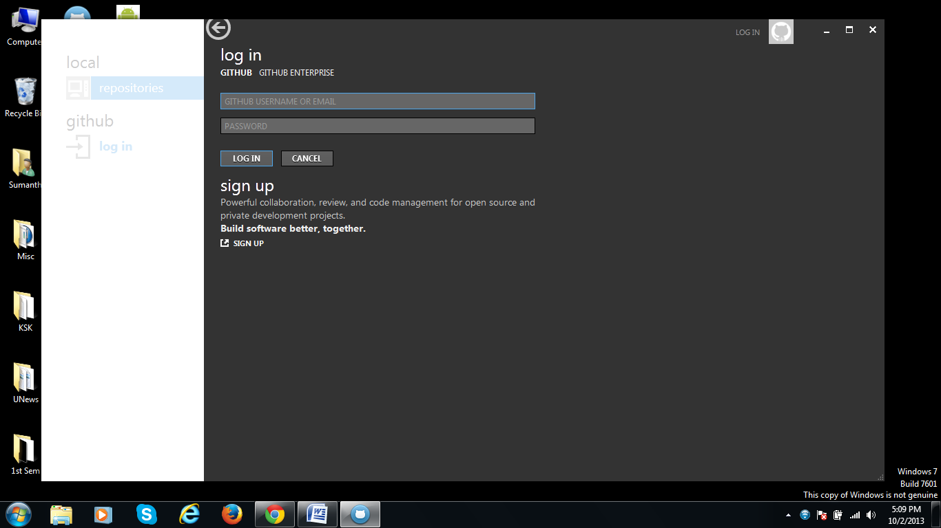

**Step 4:** Repositories in the local system.

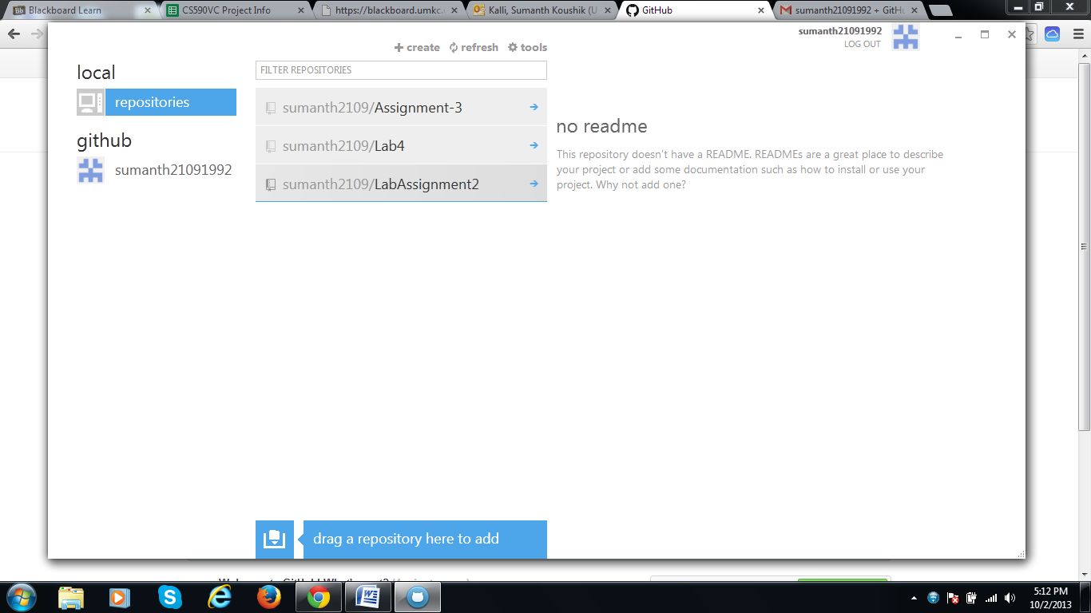

**Step 5:** A Repository is now created in this account.

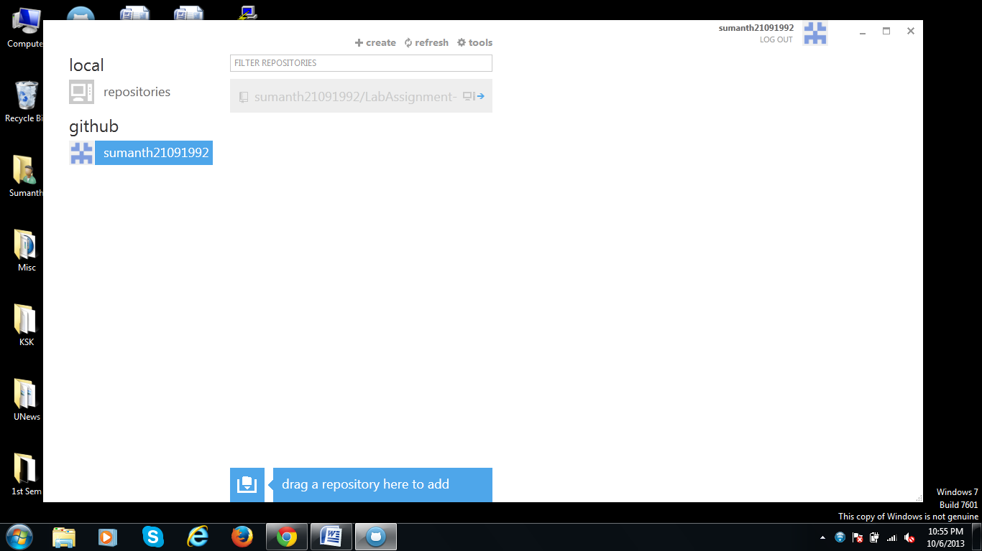

**Step 6:** The files are to be uploaded into Github in local system.

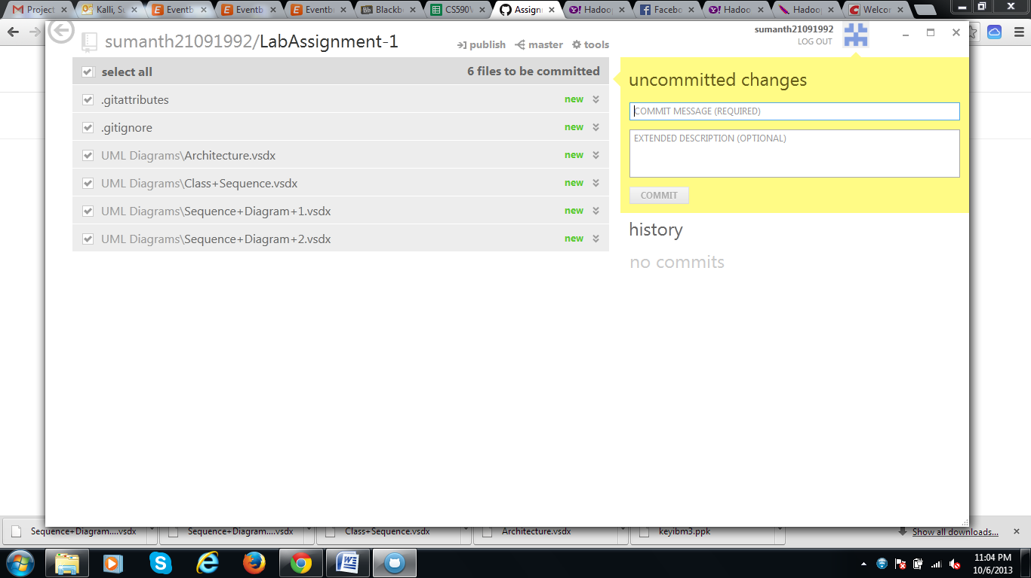

**Step 7:** The files are to be synced in order to make them available online.

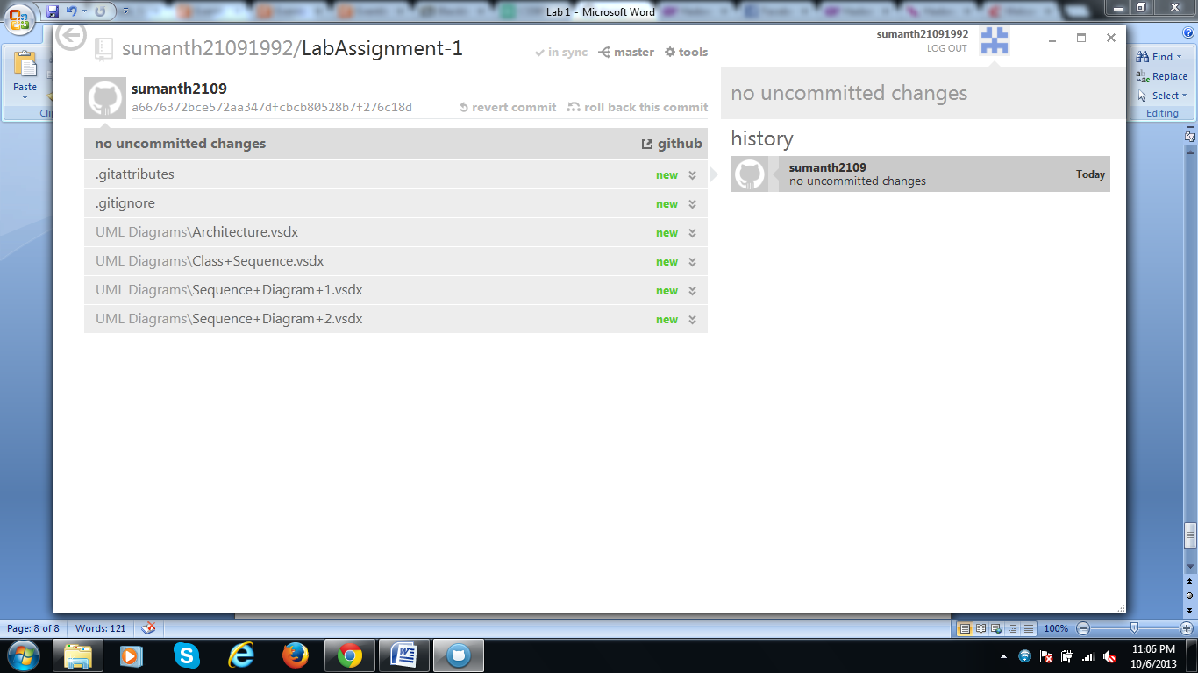

**Step 8:** The synced files can be seen online from the online Github account from www.github.com

